**Apache Airflow** is used for the scheduling and *orchestration of data pipelines* or workflows. Orchestration of data pipelines refers to the sequencing, coordination, scheduling, and managing complex data pipelines from diverse sources.

The Airflow platform lets you build and run workflows, which are represented as Directed Acyclic Graphs (DAGs). A sample DAG is shown in the diagram below.

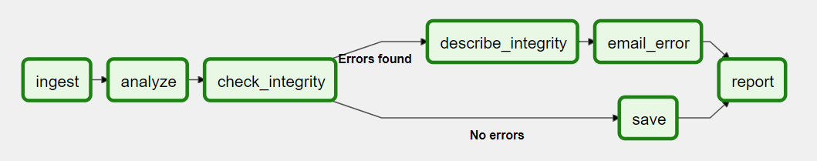

In Airflow, these workflows are represented as Directed Acyclic Graphs (DAG).

DAGs. In Airflow, a DAG – or a Directed Acyclic Graph – is **a collection of all the tasks you want to run, organized in a way that reflects their relationships and dependencies**.

**Components/Achitecture of Airflow**

1. **Webserver.**

This is a Flask web server that exposes a user interface that lets users manage, debug and inspect a workflow and its tasks.

1. **Scheduler.**

A scheduler that essentially performs two certain tasks; It schedules and triggers workflows and additionally it also submits to the executor all the of the scheduled workflows. The scheduler uses the executor to run tasks that are ready.

1. **Executer.**

The executor is responsible for running tasks. An Airflow installation can have only one executor at any given time. The executor is defined in the [core] section of the Airflow configuration file (airflow.cfg).

The local executors include [DebugExecutor](https://airflow.apache.org/docs/apache-airflow/stable/executor/debug.html), [LocalExecutor](https://airflow.apache.org/docs/apache-airflow/stable/executor/local.html) and [SequentialExecutor](https://airflow.apache.org/docs/apache-airflow/stable/executor/sequential.html). Some of the remote executors are [CeleryExecutor](https://airflow.apache.org/docs/apache-airflow/stable/executor/celery.html) and [KubernetesExecutor](https://airflow.apache.org/docs/apache-airflow/stable/executor/kubernetes.html).

## **Queue**

Once the scheduler identifies tasks which can be triggered, it will push them into a Task Queue in the right order they are supposed to be executed.

## **Workers**

Airflow workers are used to execute the assigned tasks.

1. Database



